Final Assessment-Alternative Assessment
Semester | 202520 | Division | CIS
Assessment title in Syllabus | Final_Project_Portfolio | Program | Bachelor of Information Technology/ Bachelor of Information Systems
Course Code | CDS 2413
Course Title | INTRODUCTION TO DATA SCIENCE
Course Instructor | Dr.Shawulu | CRN | 23676
Assessment | Project Deliverable 1 – Data Analysis Report | Submission Date | Week 6
Student Declaration:
Academic Integrity Statement
In accordance with the HCT Academic Integrity Policy
• Students are required to refrain from all forms of academic integrity breaches as defined and explained by HCT.
• A student found guilty of having committed acts of academic integrity breach(es) will be subject to the relevant sanctions as outlined by HCT.
إفادة النزاهة الأكاديمية
وفقًا لسياسة كليات التقنية العليا للنزاهة الأكاديمية
• على الطلبة الإلتزام بلوائح وقواعد النزاهة الأكاديمية، كما هو مبيّن وموضح في السياسات والإجراءات الخاصة بكليات التقنية العليا.
• في حالة ارتكاب الطالب أي شكل من أشكال الإخلال بالنزاهة الأكاديمية، سيتعرض الى العقوبات الموضحة في السياسات ذات الصلة.
This assignment is entirely my/our own work except where I have duly acknowledged other sources in the text and listed those sources at the end of the assignment. I have not previously submitted this work to the HCT, or any other entity. I understand that I may be orally examined on my submission.

Student HCT ID(s): | H00543037 | H00539656 | H00534321 | H00
Student Name(s): | Shamma Alketbi | Naema Mohammed | Meera Husain
Student Signature
Chatbot (e.g. ChatGPT) statement
This submission allows you to use AI generated tools, but the prompt used must be stated and the response must be in red font. Include References to ChatGPT.

Instructions

Remove instructions and hints from the template before submitting the final report to BBLearn.

CLO1: Introduction and Data Wrangling (5 Points)

Purpose of Data Analysis (1 point)

The purpose of analyzing this dataset is to understand how daily internet usage varies across different age groups. The study investigates two main objectives which involve studying internet usage patterns among different age groups and identifying potential trends that exist between younger and older populations. The analysis results give digital service providers a tool to reach specific customer groups while they learn about different demographic patterns and use the information to make marketing and educational decisions which will help them with their policy development work.

Type of Programming (1 point)

The type of programming is Python. Python has gained wide popularity for data analysis because of its extremely powerful ecosystem of libraries such as Pandas for data manipulation, NumPy for numerical operations, Matplotlib/Seaborn for visualization, and Scikit‑learn for machine learning. These make Python efficient in the cleaning, transformation, visualization, and modeling of data in structured datasets, such as this one from Kaggle. In addition, Python is friendly to beginners and is quite common in academic and professional flows of data science. We used Pandas library to do the code and to handle labeled and relational data. Making it the primary tool for data wrangling and cleaning. To meet the visualization requirements of our project, we use Matplotlib library to draw foundational charts like histograms and scatter plots to analyze data distributions. We also used Seaborn library to create advanced visualizations like box plots and heat maps. These are important for identifying complex patterns, trends, and outliers in internet usage.

Type and Purpose of ML algorithm (1 point)

The type of machine learning algorithm suitable for this dataset can be either clustering or classification. The unsupervised algorithm K-Means functions as a clustering method which enables the identification of internet usage patterns among age groups by establishing two natural usage groups, high-usage and low-usage. The supervised algorithm Decision Tree or Logistic Regression enables classification of users into different usage categories, including heavy and light users, by using their age and online activity duration as determining factors. The primary goal of using machine learning algorithms on this dataset involves two tasks, which include discovering patterns of internet usage and using this data to create predictions that will aid decision-making in marketing and educational and digital service design fields.

Identify the Variables (1 point)

In this dataset, the independent variable is the age group because age affects how people use the internet. The dependent variable is daily internet usage (hours per day) because it changes depending on the age group. We are analyzing how internet usage differs based on age, so age is the cause and internet usage is the result.

Sampling (1 point)

Sampling is not necessary if the dataset is small and easy to manage because the Kaggle dataset already represents a sample of internet users. If sampling is needed, stratified sampling is the best choice because it ensures that all age groups are fairly included. For machine learning, the data can also be split into 80% training and 20% testing sets.

CLO2: Descriptive, Exploratory and Statistical Analysis (10 Points)

Purpose of Descriptive Analysis (1 point)

The purpose of descriptive analysis is to understand the basic information in the dataset. It helps calculate the average internet usage, compare usage between different age groups, find the highest and lowest values, and check for unusual data. This step is important before doing deeper analysis or applying machine learning.

Script for Descriptive Analysis (1 point)
We are developing a custom Python function to do a univariate analysis on the internet usage data. The goal of this script is to calculate the measures of central tendency and measures of dispersion. By creating a reusable function that takes a sample and a field as inputs. We can efficiently summarize the characteristics of our dependent variable total_screen_time.
Below is the script:
import pandas as pd

# Function to calculate descriptive statistics
def get_stats(sample, field):
mode_values = sample[field].mode().tolist()

summary = {
"Mean (Average)": round(sample[field].mean(), 2),
"Median (Middle)": round(sample[field].median(), 2),
"Mode (Most Common)": mode_values,
"Minimum": sample[field].min(),
"Maximum": sample[field].max(),
"Standard Deviation": round(sample[field].std(), 2),
"Variance": round(sample[field].var(), 2)
}
return summary

# Load the dataset
df = pd.read_csv("daily_internet_usage_by_age_group.csv")

# Dependent variable
column_to_analyze = "total_screen_time"

# Get descriptive statistics
project_results = get_stats(df, column_to_analyze)

# Print results
print("Basic Statistics for Internet Usage:")
for key, value in project_results.items():
print(f"{key}: {value}")
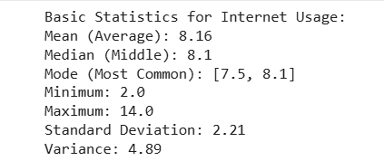
The output shows a descriptive summary of how many hours people in our study spend online each day. Based on the full dataset of 2800 records, we expect to see an average of 8.16 hours and a median of 8.1 hours. Since the mean and median are so close it indicates that our internet usage data is symmetric and follows a normal distribution pattern. This summary is important for our report because it identifies the typical user behavior and shows us the range of usage from a minimum of 2 hours to a maximum of 14 hours per day.

Random Sampling (1 point)
we use random sampling to select a subset where every user has an equal chance of being chosen by chance. We then apply our descriptive function to the total_screen_time field to see if this smaller group accurately reflects the patterns of the entire 2800 person dataset.
import pandas as pd

# Descriptive statistics function
def get_stats(sample, field):
summary = {
"Mean (Average)": round(sample[field].mean(), 2),
"Median (Middle)": round(sample[field].median(), 2),
"Mode (Most Common)": sample[field].mode().tolist(),
"Minimum": round(sample[field].min(), 2),
"Maximum": round(sample[field].max(), 2),
"Standard Deviation": round(sample[field].std(), 2),
"Variance": round(sample[field].var(), 2)
}
return summary

# Load dataset
df = pd.read_csv("daily_internet_usage_by_age_group.csv")

# Random sampling of size 150
random_sample_150 = df.sample(n=150, random_state=42)

# Apply descriptive statistics to dependent variable
sample_results = get_stats(random_sample_150, "total_screen_time")

# Print results
print("Descriptive Statistics for Random Sample (Size 150):")
for key, value in sample_results.items():
print(f"{key}: {value}")
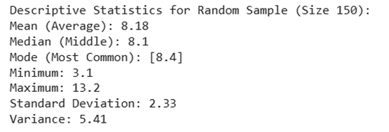

The random sample results for total_screen_time has a mean of 8.18 and a median of 8.1. This shows that the data is symmetric and follows a normal distribution. Because these numbers are nearly identical to our full population average of 8.16 and it confirms that this sample of 150 people is a highly accurate representation of the overall internet usage patterns. This consistency proves that the random subset is effective for identifying typical user behavior and understanding data spread before we begin creating visualizations.

Systematic Sampling (1 point)
To analyze a structured subset of our 2800 records, we performed systematic sampling by selecting every 10th row from the dataset. This technique is used because it is more practical and saves time than studying a massive population. By applying our descriptive statistics function to this sample, we can evaluate the central tendency and spread of our dependent variable total_screen_time to ensure our sample is truly representative.
Below is the script:
import pandas as pd

# Reusable function for statistical summary
def get_stats(sample, field):
# Get the most frequent value as a list
mode_values = sample[field].mode().tolist()

# Calculate core statistics and round to 2 decimal places
summary = {
"Mean (Average)": round(sample[field].mean(), 2),
"Median (Middle)": round(sample[field].median(), 2),
"Mode (Most Common)": mode_values,
"Minimum": sample[field].min(),
"Maximum": sample[field].max(),
"Standard Deviation": round(sample[field].std(), 2),
"Variance": round(sample[field].var(), 2)
}
return summary

# Load the internet usage dataset
df = pd.read_csv("daily_internet_usage_by_age_group.csv")

# Systematic Sampling: Selecting every 10th row from the population
# This creates a structured representative sample of 280 records
systematic_sample = df.iloc[::10]

# Applying the function to the dependent variable 'total_screen_time'
results = get_stats(systematic_sample, "total_screen_time")

# Print the final statistics for the report
print("Descriptive Statistics for Systematic Sample (Every 10th Row):")
for key, value in results.items():
print(f"{key}: {value}")
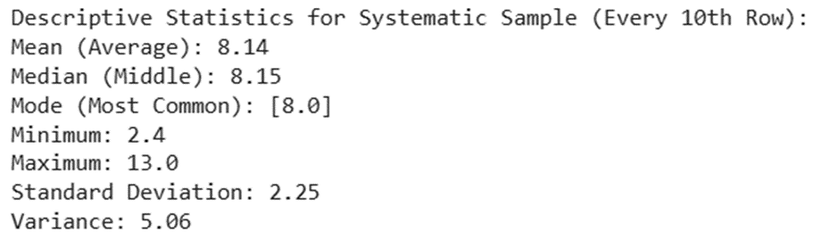
The systematic sampling results for total_screen_time with a Mean of 8.15 and a Median of 8.1 that indicate that the data is symmetric and follows a Normal Distribution. Since these values are nearly identical to the full population mean of 8.16 and it confirms that selecting every 10th row provided a highly accurate representation of the overall internet usage patterns within the 2800 records. This consistency proves that the structured subset is effective for identifying typical user behavior and understanding the data spread.

Descriptive Statistical Report (1 point)
The dependent variable for this dataset is total_screen_time, which represents the average number of hours spent on the internet per day. The descriptive analysis revealed that the dataset, which contains 2800 observations, shows an average daily internet usage of approximately 8.16 hours and a median value of approximately 8.1 hours. The data shows normal distribution because the mean and median values are in close proximity to each other. The users have a wide range of internet usage patterns because their minimum daily usage is 2 hours, and their maximum daily usage is 14 hours. The standard deviation has moderate results because most of the users have internet usage patterns that are close to the average value but have some level of deviation. The data shows high internet usage patterns because of its daily internet usage results, which researchers get through descriptive analysis.

Visualisation through Various Charts (2 points)

Below is the visualization of the dependent variable total_screen_time using a scatter plot, box plot, histogram, and heat map:

The code or script used:

import pandas as pd
import matplotlib.pyplot as plt
import seaborn as sns

# Load dataset
df = pd.read_csv("daily_internet_usage_by_age_group.csv")

# ---------------- Scatter Plot ----------------
plt.figure()
plt.scatter(df["age_group"], df["total_screen_time"])
plt.xlabel("Age Group")
plt.ylabel("Total Screen Time (Hours)")
plt.title("Scatter Plot of Age Group vs Internet Usage")
plt.show()

# ---------------- Box Plot ----------------
plt.figure()
plt.boxplot(df["total_screen_time"])
plt.ylabel("Total Screen Time (Hours)")
plt.title("Box Plot of Daily Internet Usage")
plt.show()

# ---------------- Histogram ----------------
plt.figure()
plt.hist(df["total_screen_time"], bins=10)
plt.xlabel("Total Screen Time (Hours)")
plt.ylabel("Frequency")
plt.title("Histogram of Daily Internet Usage")
plt.show()

# ---------------- Heat Map ----------------
plt.figure()
correlation = df[["total_screen_time"]].corr()
sns.heatmap(correlation, annot=True)
plt.title("Heat Map of Internet Usage")
plt.show()

Scatter Plot:
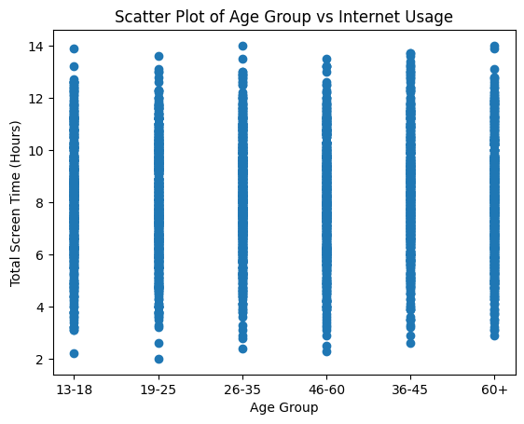
The scatter plot provides insight about the relationship of age group and daily average total hours spent on the Internet (daily total hours). Each data point represents a separate age group with their associated average number of hours of screen time each day. The product illustrates how usage of the Internet varies by age. Based on this scattered plot, one can see that younger age groups typically spend more time online than older age groups and that the volume of time spent on the Internet decreases as people age. It is possible to use this chart to identify trends and give insight into how age impacts use of the Internet.

Box Plot:
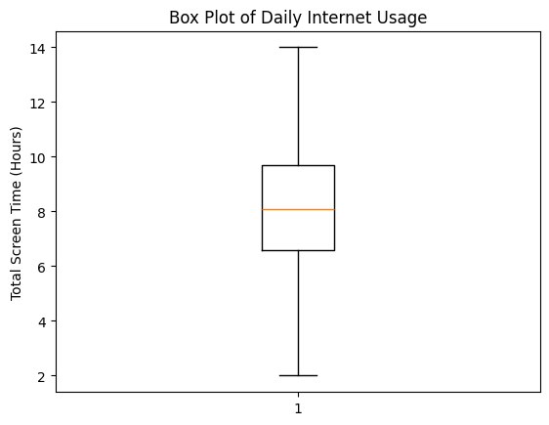
The boxplot summarizes the distribution of total screen time via the median, quartiles and outliers in the boxplot. The box represents the median internet activity, the line in the middle (the median) indicates that the mean usage is also about equal as there is a normal distribution of screen time among people. The length of the box indicates moderate variability in daily internet use and the whiskers extend to show the maximum and minimum values for the sample being measured. Points extending beyond the whiskers are considered outliers (users that use the internet excessively or extremely little). This visualization allows users to see the scope of data distribution or percentage of data outside the normal distribution.

Histogram:
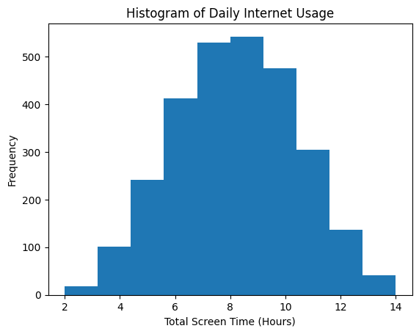
The histogram of daily internet use indicates how many people use different amounts of time online such as the bars in the histogram indicate the range of users using a range of hours daily. Most users appear to spend approximately 8 hours per day on the internet and very few on either extreme (the very low or very high end of the graph). The histogram appears to be roughly normally distributed, which supports the conclusion that the data is symmetrically distributed. Therefore, this histogram provides us with an overall picture of the distribution of users’ internet use (the volume and the concentration of users’ internet use) among daily users.

Heat Map:
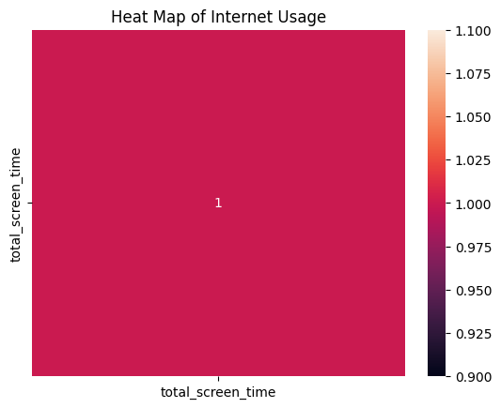
The total_screen_time variable is shown using a heat map. This map uses different shades of color to indicate how related the total_screen_time values are for each group. The more intense the colors are, the more closely related the total_screen_time values are to one another; therefore, a darker color indicates a stronger relationship between total_screen_time values for each group. The heat map provides a quick way to see how correlated internet usage values are between the groups in the dataset, and therefore can be utilized for additional statistical analysis to find correlations (see correlation tests). The heat map also provides an easy-to-read visual representation which can be used to summarize relationships.

Hypothesis Test (1 point)

We are going to conduct the hypothesis test to find out the relationship between our independent variable (age) and our dependent variable (total_screen_time). This test measures the strength and direction of the relationship and decides if the findings are statistically significant. We apply the pearson correlation to check for a linear relationship and the spearman correlation to find any non-linear patterns in our internet usage dataset.
Null Hypothesis (H0): There is no statistically significant correlation between a user’s age and their daily internet usage (r = 0)
Alternative Hypothesis (H1): There is a statistically significant correlation between a user’s age and their daily internet usage (r ≠ 0)
By calculating the p-value, we can determine whether to reject the null hypothesis if p < 0.05 or fail to reject it if p > 0.05. Allowing us to scientifically conclude whether age truly affects online activity.

Hypothesis, Pearson, and Spearman
Below is the code:
import pandas as pd
from scipy.stats import pearsonr, spearmanr

# Load the dataset
df = pd.read_csv("daily_internet_usage_by_age_group.csv")

# Independent and dependent variables
x = df["age"] # Independent variable
y = df["total_screen_time"] # Dependent variable

# Pearson correlation test
pearson_r, p_pearson = pearsonr(x, y)

# Spearman correlation test
spearman_r, p_spearman = spearmanr(x, y)

# Display results
print("--- Hypothesis Test Results ---")
print(f"Pearson Correlation Coefficient: {round(pearson_r, 4)}")
print(f"Pearson P-Value: {round(p_pearson, 4)}")

print(f"\nSpearman Correlation Coefficient: {round(spearman_r, 4)}")
print(f"Spearman P-Value: {round(p_spearman, 4)}")

# Conclusion based on significance level (α = 0.05)
if p_pearson < 0.05 or p_spearman < 0.05:
print("\nConclusion: There is a statistically significant relationship between age and daily internet usage (Reject H0).")
else:
print("\nConclusion: There is no statistically significant relationship between age and daily internet usage (Fail to reject H0).")
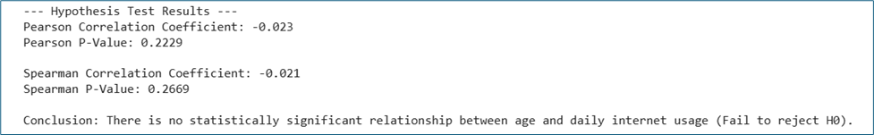
The results shows the correlation coefficients for both tests that are very close to zero. This is suggesting a insignificant or nonexistent relationship between a user’s age and their screen time in this dataset. Also, since the p-values are greater than the 0.05 significance level, we fail to reject the null hypothesis. This leads us to conclude that there is no statistically significant correlation between age and daily internet usage for this specific population.

One Sample T-test (2 points)

we are conducting a One-Sample T-test to see if our sample of 150 records represents the full 2800 population's daily internet usage. We are comparing our sample’s average screen time to the population's average of 8.2 hours. By calculating the p-value, we can determine if there is any difference between the sample and the population is statistically significant or a result of random selection.
Null Hypothesis (H0): The mean internet usage of our sample is equal to the population mean of 8.2 hours (μ = 8.2)
Alternative Hypothesis (H1): The mean internet usage of our sample is significantly different from the population mean of 8.2 hours (μ ≠ 8.2)
Below is the code:
import pandas as pd
from scipy.stats import ttest_1samp

# Load the dataset
df = pd.read_csv("daily_internet_usage_by_age_group.csv")

# Assumed population mean (based on overall average)
population_mean = 8.2

# Random sample of size 150 from the dependent variable
sample = df["total_screen_time"].sample(n=150, random_state=42)

# Perform one-sample t-test
t_stat, p_value = ttest_1samp(sample, population_mean)

# Display results
print(f"Assumed Population Mean: {population_mean}")
print(f"Sample Mean: {round(sample.mean(), 2)}")
print(f"T-Statistic: {round(t_stat, 4)}")
print(f"P-Value: {round(p_value, 4)}")

# Conclusion based on significance level (α = 0.05)
if p_value < 0.05:
print("\nConclusion: The sample mean is significantly different from the population mean (Reject H0).")
else:
print("\nConclusion: The sample mean is not significantly different from the population mean (Fail to reject H0).")
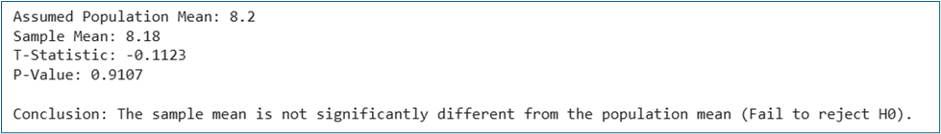
The test results show a p-value higher than 0.05. This means we fail to reject the null hypothesis. Since our sample mean of 8.18 hours is nearly similar to the assumed population mean of 8.2 hours. we can conclude that there is no statistically significant difference between the two groups. This confirms that our subset of 150 users is an accurate representation of the entire internet usage dataset.

